


TC-ND519A Spec:2/E/V2.0
Decoding machine

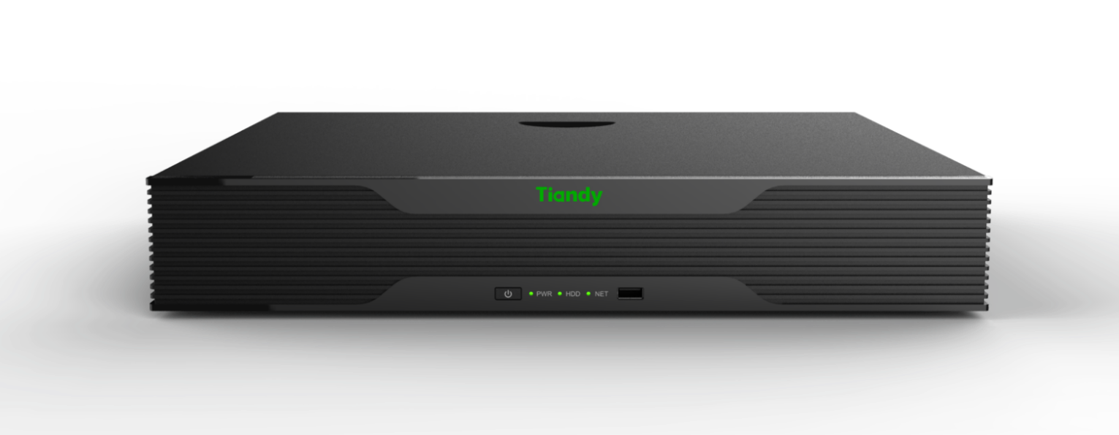

Features

- 6/9/12/16-channel decoders now support any combination of mixed cascades, up to 4 units can be cascaded, and can be cascaded with V1.0 version
- Support 4K high-resolution input and output
- Support 2-channel local HD video input + 9-channel video decoding output
- HD video input supports HDMI
- Support H.264/265 and other encoding formats
- Supports H.265, H.264 Baseline/Main/High-profile encoding levels
- Support 16 system plans and quick retrieval
- Audio decoding supports G.711A, G.711U, AAC, ADPCM audio format decoding
- The number of decoding channels of the whole machine is 144
- Supports free division of decoding performance
- Supports 9-screen cascade splicing, window opening, overlay, roaming, cross-screen and other functions
- Supports window opening, overlay, roaming, cross-screen and other functions
- Any signal can achieve stepless zoom function
- Interactive visual software operation terminal, supports PAD control using Safari browser
- Support alarm input/output function setting, support arming and disarming time setting
- Support alarm linkage switching
- Support adding 64 channels of patrol decoding to a single screen
- Support video file decoding and output on the wall
- Support network keyboard/RS485 keyboard to control the front end through the decoder
- Support transparent channel
- HD video input can be segmented, spliced, windowed, roamed, and overlaid along with decoding
- Support ONVIF standard protocol to access front-end devices
- Support RTP/RTSP protocol for device browsing
- Supports decoding streams from encoding devices using RTSP URL
- Support platform integration of devices via SDK
- Support GB28181 protocol access platform
- Support WEB or platform access, configuration and management
- Support remote acquisition and configuration of parameters, support remote export and import of parameters
- Support remote acquisition of system operation status and system logs
- Support remote restart, restore default configuration, upgrade and other daily maintenance
- The whole machine contains 1 reset button
- Display screen compatibility: LCD screen

Technical Specifications:
Output parameters
Output Interface | 9 HDMI outputs
HDMI output resolution | 4k (3840*2160@30Hz) (only supported by ports 1, 5, and 9 in HD mode)  1920*1080@60Hz, 1280*720@60Hz, 1280*800@60Hz,  1440*900@60Hz, 1280*1024@60Hz, 1366*768@60Hz,  1024*768@60Hz, 800*600@60Hz
Input parameters
input interface | 2-way HDMI
HDMI input resolution | 4K (3840*2160@30Hz), 1920*1080@60Hz, 1440*900@60Hz, 1366*768@60Hz, 1280*1024@60Hz, 1280*960@60Hz, 1280*800@60Hz, 1280*720@60Hz, 1024*768@60Hz, 800*600@60Hz
Splicing capability
Splicing control function | Supports window opening, overlay, roaming, cross-screen and other functions
Splicing capability | 1*2, 1*3, 1*4; 2*1, 2*2, 2*3, 2*4; 3*2, 3*3; 4*2
Window/Roaming | 1*1, 1*2, 1*3, 1*4, 2*1, 2*2, 2*3, 2*4, 3*2, 4*2: 4 windows per screen
Basic parameters
IE Management | Support IE output setting function for each group, alarm input/output function setting, arming and disarming time setting
Alarm switch | Support alarm linkage switching
Patrol decoding | Support adding 64 channels of patrol decoding to a single screen
Video decoding | Support video file decoding and output on the wall
Keyboard Control | Support network keyboard RS485 keyboard to control the front end through the decoder
Transparent channel | Support transparent channel transmission
Network protocol | Support RTSP, TCP/IP, RTP, UDP, HTTP, IGMP, Telnet, ICMP, ARP and other network protocols
Open and compatible | Support ONVIF/GB28181 protocol
Management | Support WEB or platform access, configuration and management
Configuration | Support remote acquisition and configuration of parameters, support remote export and import of parameters
log | Support remote acquisition of system operation status and system logs
system maintenance | Support remote restart, restore default configuration, upgrade and other daily maintenance
Decoding parameters
Decoding channels | Single machine 144 channels
Decoding capability | 12 -channel 1200W@30fps, 24 -channel 800W@30fps, 30 -channel 600W@30fps, 36 -channel 500W@30fps, 48 -channel 400W@30fps, 60- channel 300W@30fps, 96 -channel 1080P@30fps
Video Format | S+265, H.265, H.264, MPEG4
audio format | G.711A, G.711U, AAC, ADPCM
Audio sampling rate | 8K, 16K, 32K, 48K
Stream Access Protocol | Private, onvif, rtsp
Client streaming | Private, onvif, GB28181 (coordinated with platform streaming)
Number of screen divisions | Non-HD mode:  1*1, 1*2, 1*3, 2*1: 1/2/3/4/6/8/9/10/13/16  2*2, 1*4, 2*3, 2*4, 3*2, 4*2: 1/2/3/4/6/8/9/10/13/16/20/25/36  3*3: 1/2/3/4/6/8/9/10/13/16/20/25/36/40/64/81  HD Mode:  1*1, 1*2, 1*3, 2*1: 1/2/3/4/6/8/9/10/13/16/20/25/36/40/64
Maximum access bandwidth | 640Mbps​
Interface parameters
Network Interface | 2 RJ45 10M/100M/1000Mbps adaptive Ethernet ports
Audio | 1-way 3.5mm audio input interface, 1-way 3.5mm audio output interface
Call the police | 8-way alarm input, 8-way alarm output (green terminal)
Serial Interface | 2 232 (RJ45*1, green terminal*1); 2 485 (green terminal)
USB interface | USB3.0 1, USB2.0 2 (1 on the front panel, 1 on the rear panel)
reset button | support
Optical port | not support
Dual power | not support
General Specifications
power supply | AC 220V
power | ≤55W
Operating temperature | -10℃--＋55℃
Working humidity | 10%--90%
size | 441 mm (width) * 341 mm (depth) * 75 mm (height including feet)
weight | 5.25 kg​​
Single box size | 540 (L) 175 (W) 455 (H)
Single box weight | 6.55 kg​​
Integrated package size | 565(L)485(W)750(H)
Integrated package weight | 28.3kg
Dimensions:

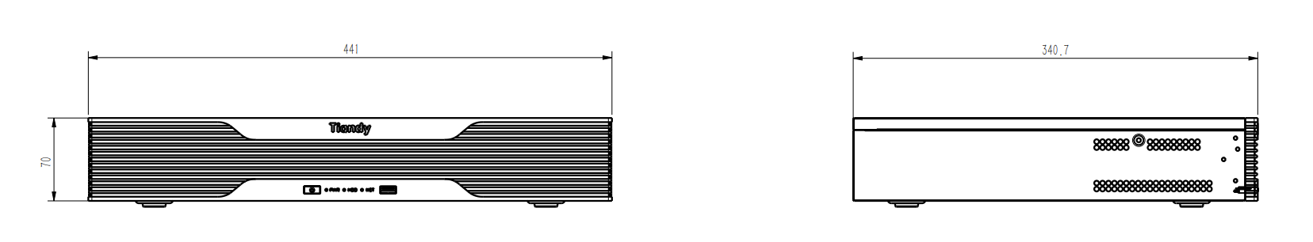
Hardware interface:
