


TC-ND514A Spec: E/V2.0
Decoding machine

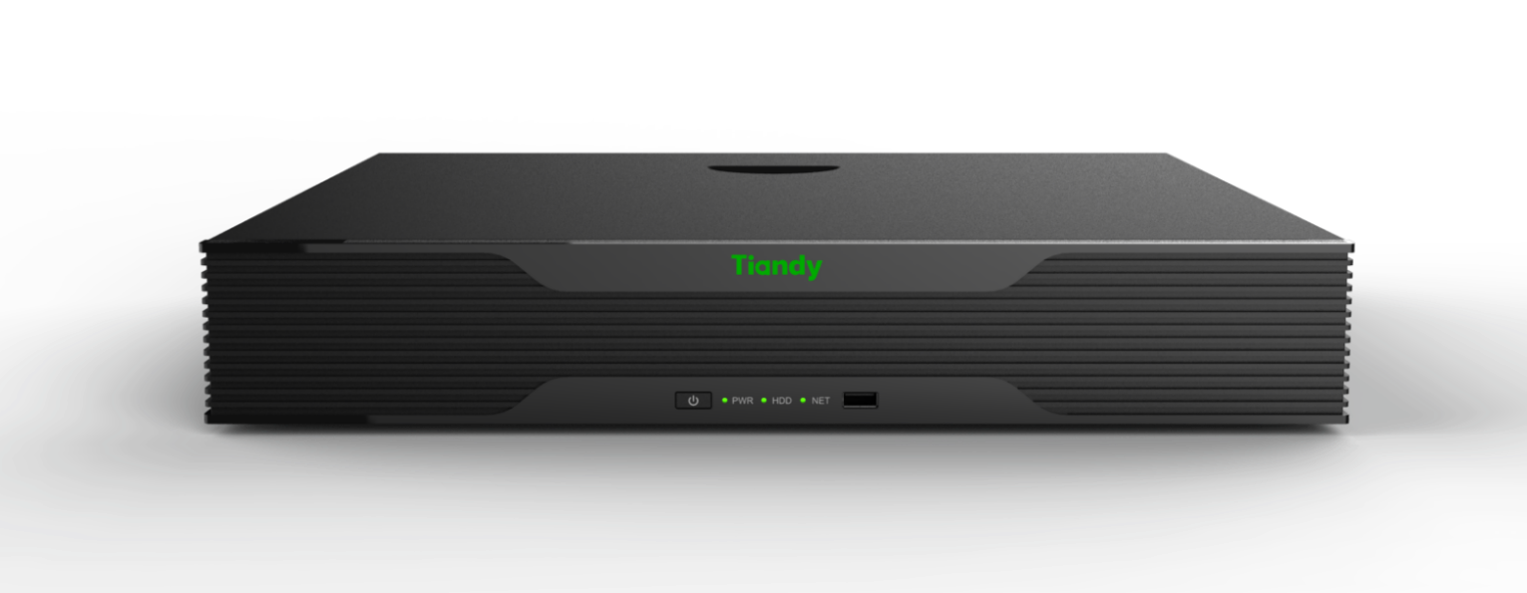

Features

- Support 4-channel HD video decoding output
- Support H.264/265 and other encoding formats decoding
- Supports H.265, H.264 Baseline/Main/High-profile encoding levels
- The whole machine supports 4 HDMI outputs
- Decoding capability: 4-channel 12MP/8-channel 4K/12-channel 5MP/16-channel 4MP/ 20- channel 3 MP/ 32-channel 1080P
- The number of decoding channels of the whole machine is 64
- Supports free division of decoding performance
- HDMI/VGA output resolution: 4k (3840*2160@30Hz) (only port 1 supports in HD mode) , 1920*1080@60Hz, 1280*720@60Hz, 1280*800@60Hz, 1440*900@60Hz, 1280*1024@60Hz, 1366*768@60Hz, 1024*768@60Hz, 800*600@60Hz
- Support video decoding resolution: 3840*2160@30/25fps; 2560*1600@30/25fps; 2048*1536@30/25fps; 1600*1200@30/25fps; 1920*1080@60/50/30/25fps; 1280*720@60/50/30/25fps; 704*576@60/50/30/25fps; 352*288@60/50/30/25fps
- Interactive visual software operation terminal, supports PAD control using Safari browser
- Support adding 64 channels of patrol decoding to a single screen
- Support video file decoding and output on the wall
- Support ONVIF standard protocol to access front-end devices
- Support RTP/RTSP protocol for device preview
- Supports decoding streams from encoding devices using RTSP URL
- Support platform integration of devices via SDK
- Support GB28181 protocol access platform
- Support WEB or platform access, configuration and management
- Support remote acquisition and configuration of parameters, support remote export and import of parameters
- Support remote acquisition of system operation status and system logs
- Support remote restart, restore default configuration, upgrade and other daily maintenance
- The whole machine contains 1 reset button

Technical Specifications:
Output parameters
Output Interface | 4 HDMI outputs
HDMI output resolution | 4k (3840*2160@30Hz) (only supported by port 1 in HD mode)  1920*1080@60Hz, 1280*720@60Hz, 1280*800@60Hz,  1440*900@60Hz, 1280*1024@60Hz, 1366*768@60Hz,  1024*768@60Hz, 800*600@60Hz
Basic parameters
IE Management | Support IE output setting function for each group, alarm input/output function setting, arming and disarming time setting
Alarm switch | Support alarm linkage switching
Patrol decoding | Support adding 64 channels of patrol decoding to a single screen
Video decoding | Support video file decoding and output on the wall
Keyboard Control | Support network keyboard RS485 keyboard to control the front end through the decoder
Transparent channel | Support transparent channel transmission
Network protocol | Supports RTSP , TCP/IP, RTP, UDP, HTTP, IGMP, Telnet, ICMP, ARP and other network protocols
Open and compatible | Support ONVIF/GB28181 protocol
Management | Support WEB or platform access, configuration and management
Configuration | Support remote acquisition and configuration of parameters, support remote export and import of parameters
log | Support remote acquisition of system operation status and system logs
system maintenance | Support remote restart, restore default configuration, upgrade and other daily maintenance
Decoding parameters
Decoding channels | Single machine 6 4 channels
Decoding capability | 4 -channel 1200W@30fps, 8 -channel 800W@30fps, 10 -channel 600W@30fps, 12 -channel 500W@30fps, 16 -channel 400W@30fps, 20 -channel 300W@30fps, 32 -channel 1080P@30fps
Video Format | S+265, H.265, H.264, MPEG4
Stream Access Protocol | Private, onvif, rtsp
Client streaming | Private, onvif, GB28181 (coordinated with platform streaming)
Maximum access bandwidth | 640Mbps​
Interface parameters
Network Interface | 2 RJ45 10M/100M/1000Mbps adaptive Ethernet ports
Audio | not support
Call the police | not support
Serial Interface | not support
USB interface | USB3.0 1, USB2.0 2 (1 on the front panel, 1 on the rear panel)
reset button | support
Optical port | not support
Dual power | not support
General Specifications
power supply | DC12V
power | ≤ 20 W
Operating temperature | -10℃--＋55℃
Working humidity | 10%--90%
size | 441 mm (width) * 341 mm (depth) * 75 mm (height including feet)
weight | 4.15 kg
Single box size | 540 (L) 175 (W) 455 (H)
Single box weight | 5.65 kg
Integrated package size | 565(L)485(W)750(H)
Integrated package weight | 2 4.6 kg
Dimensions:

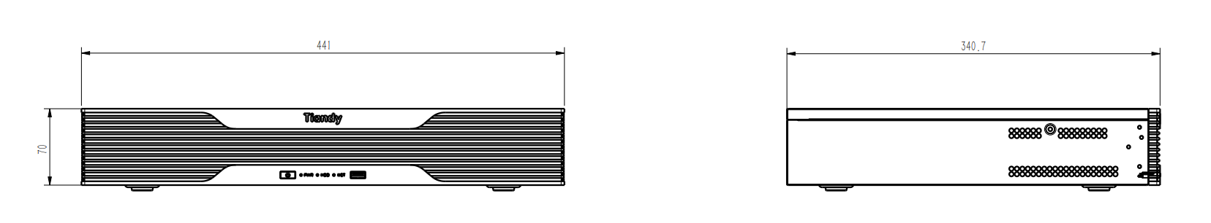
Hardware interface:
